**Choose the first scenario**

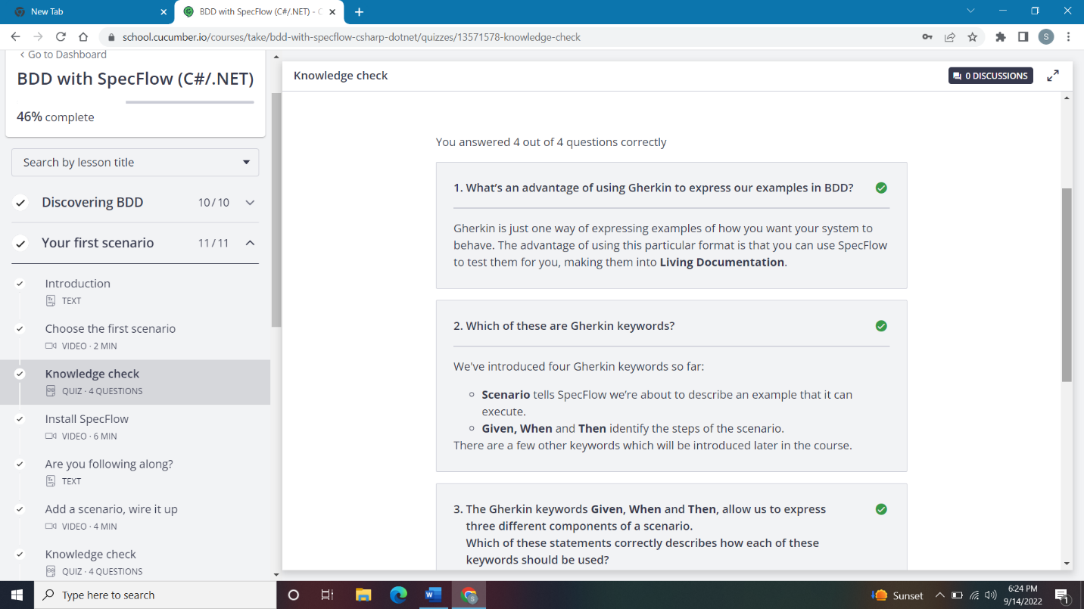

### Install SpecFlow

### Sketch out the solution

### Make the scenario pass

